The following is a summary of the Cibersort Analysis:

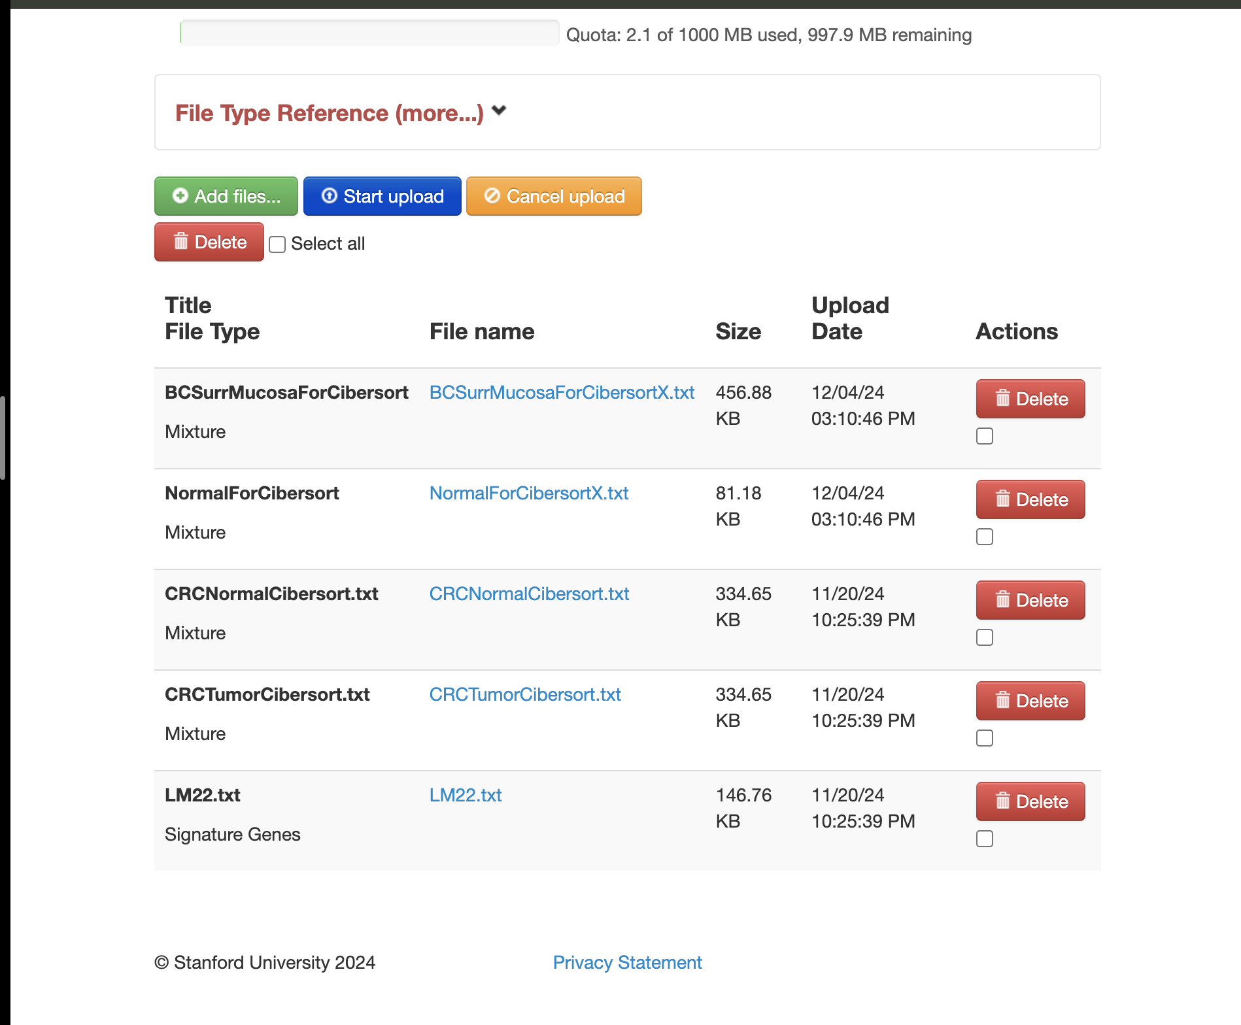

First, I uploaded the two files I wanted to run through Cibersort: “BCSurrMucosaForCibersort” and “NormalForCibersort”, making sure to upload each file as a Mixture.

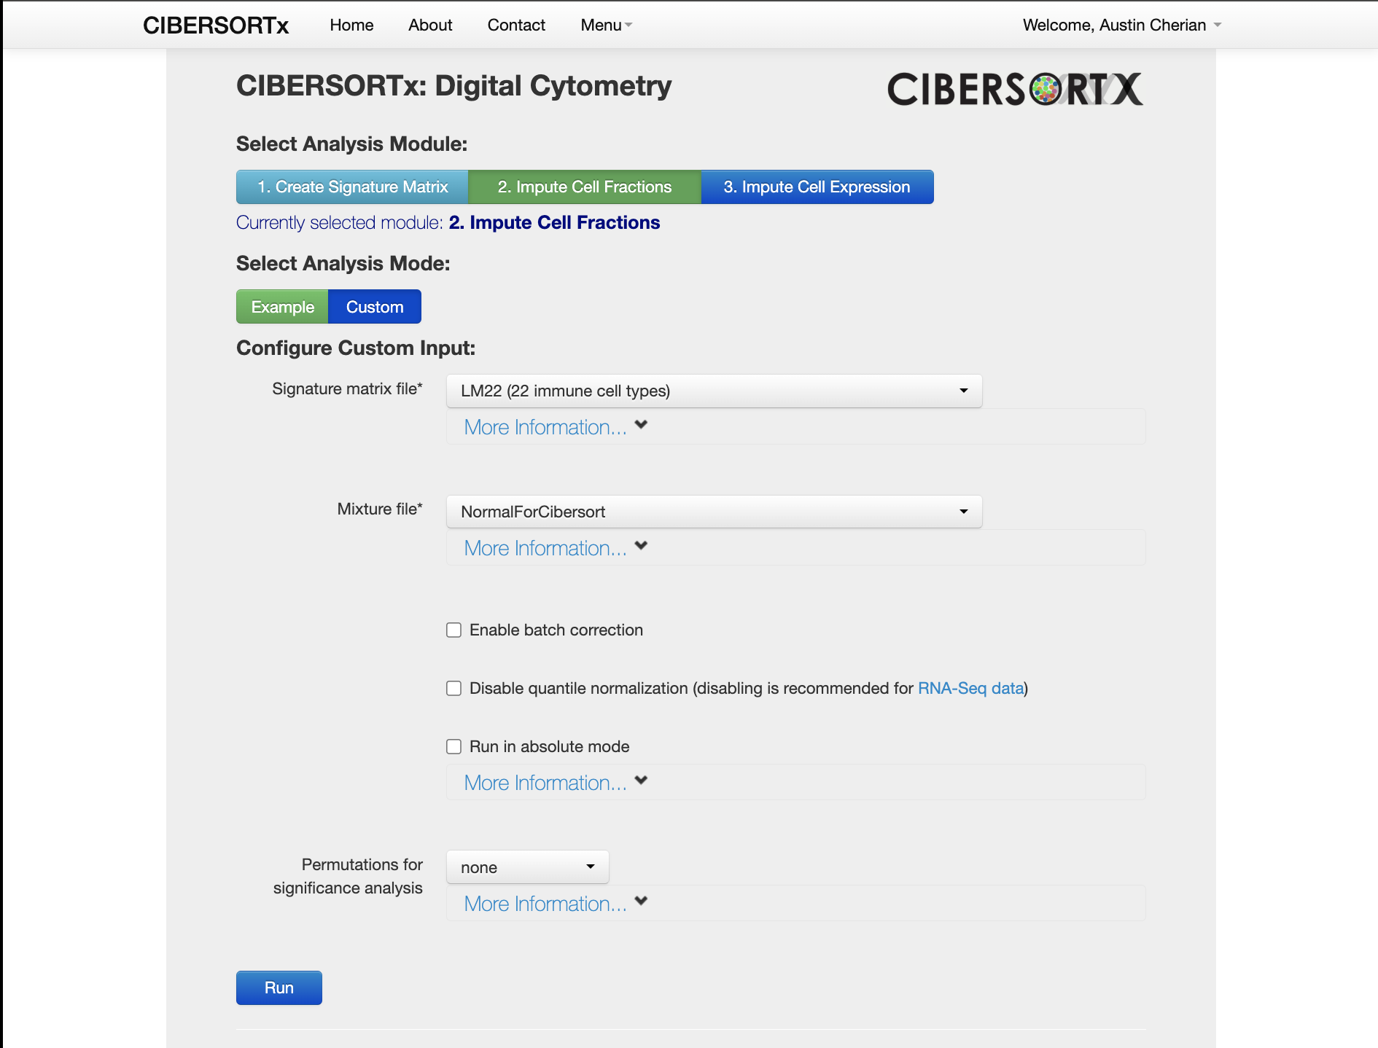

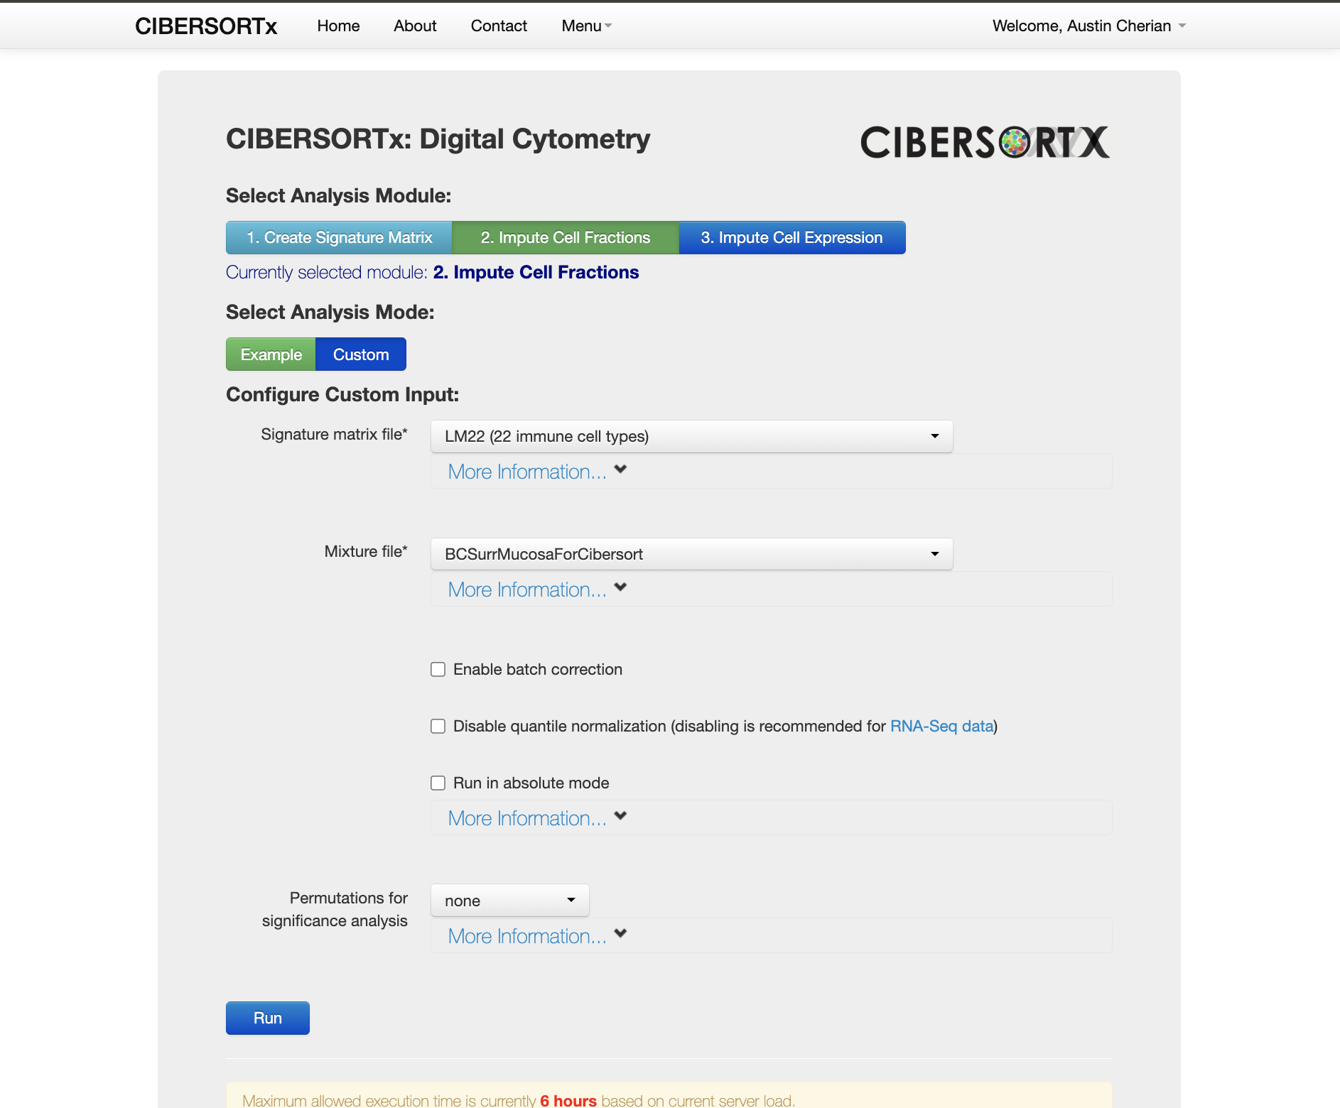

Next, I ran each file through the Cibersort analysis through the workflow:

I made sure to select the “2. Impute Cell Fractions” Analysis Module, and the “Custom” Analysis Mode. For the Custom Input, I selected the “LM22” signature matrix file. I added the “NormalForCibersort” file as the mixture file for one job and the “BCSurrMucosaForCibersort” as the mixture file for the second job.

In both jobs, I removed the checkbox to “disable quantile normalization”.

Finally, I ran both jobs.

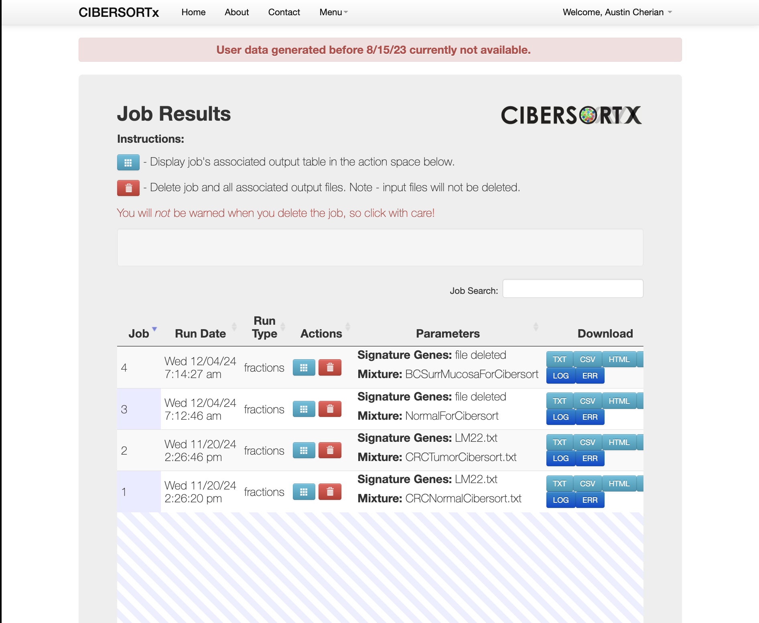

I then navigated to the “Job Results” page to look at the results of my Cibersort Analysis for both the “BCSurrMucosaForCibersort” and the “NormalForCibersort” files.

Here are some screenshots of what the results looked like for the “BCSurrMucosaForCibersort” and the “NormalForCibersort” files respectively:

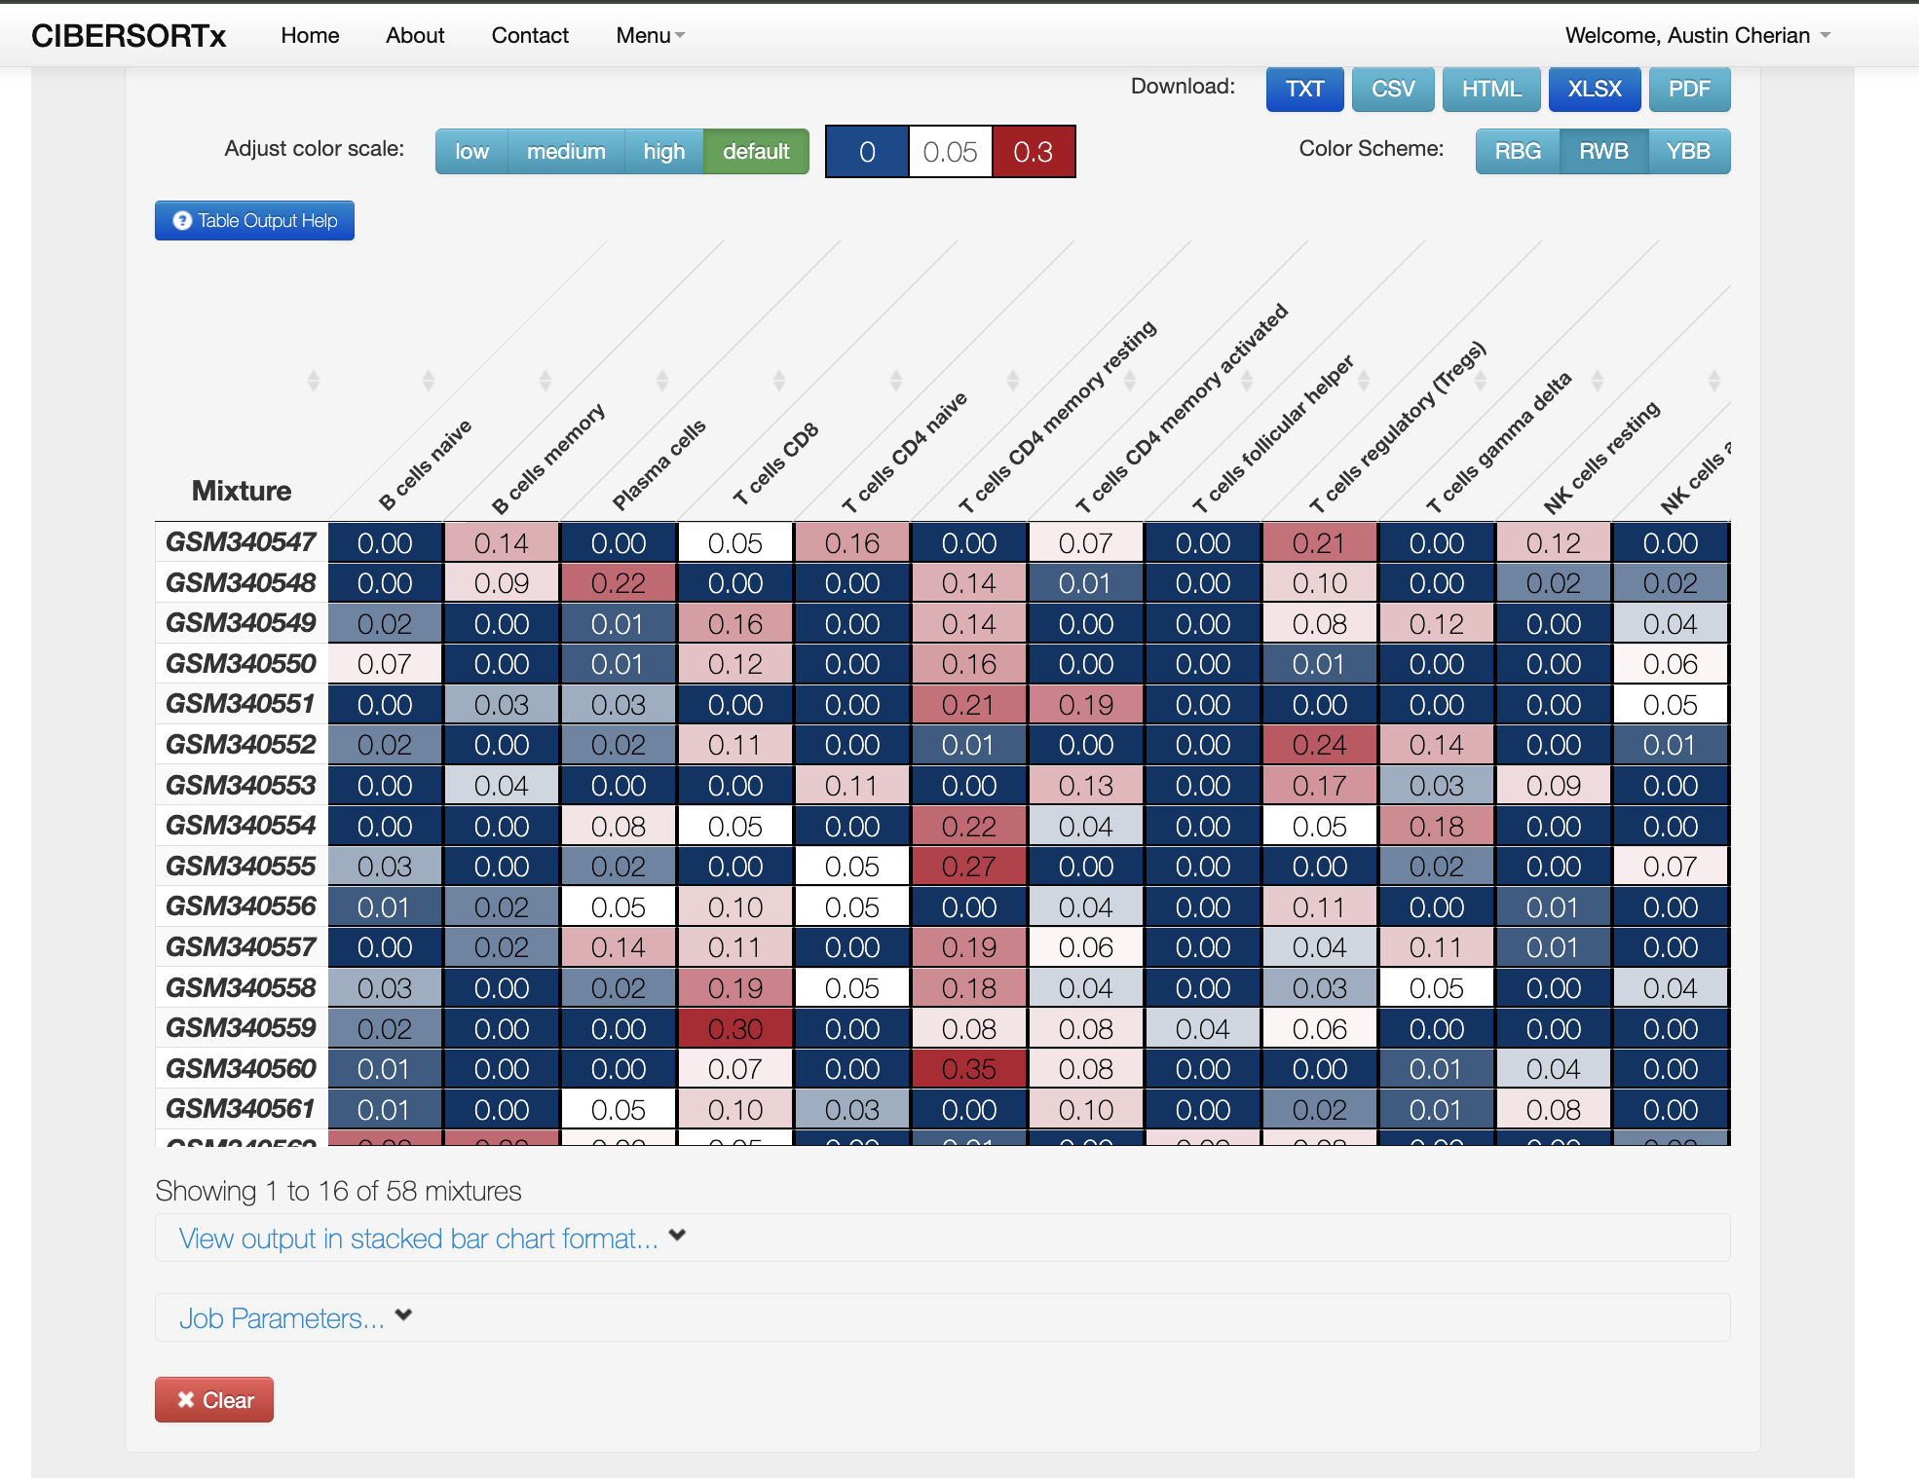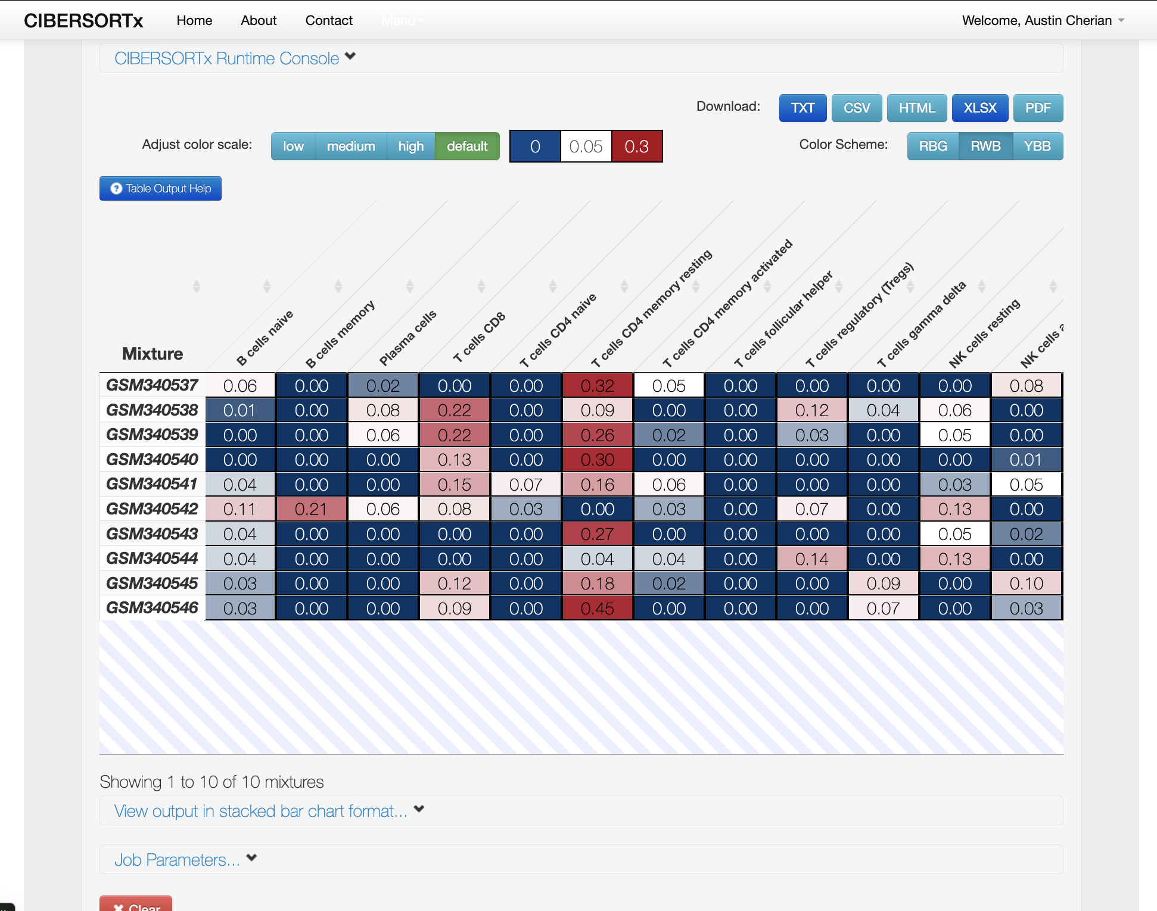

* Find and list the **top 5 types of immune cells** that are most prevalent in each of the two groups

Top 5 most prevalent immune cells in “Normal” group

1. T cells CD4 memory resting
2. Macrophages M2
3. Mast cells resting
4. T cells CD8
5. Monocytes

Top 5 most prevalent immune cells in “BCSurrMucoa” group

1. T cells CD4 memory resting
2. Macrophages M2
3. Mast cells resting
4. T cells regulatory (Tregs)
5. T cells CD8

* *Find the average of the fractions for each cell type across all samples in a group*

The following are the averages of the fractions for each cell type across all samples in each group:

For “BCSurrMucosaForCibersort” Group

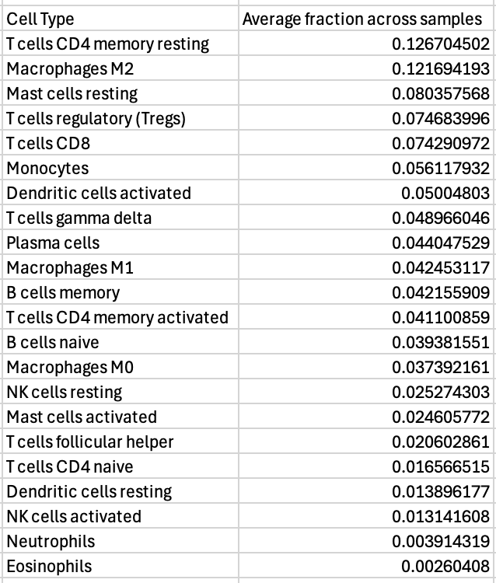

For “NormalForCibersort”

